**BANK LOAN REPORT QUERY DOCUMENT**

1. **BANK LOAN REPORT | SUMMARY**

KPI’s:

------------------------------------Summary Page------------------------------------

Total Loan Applications:

select count(*) as Total_Loan_Application from bank_loan_data;

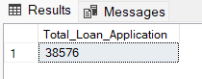

MTD Loan Applications:

select count(*) as MTD_Total_Loan_Application from bank_loan_data where MONTH(issue_date) = (select MAX(MONTH(issue_date)) from bank_loan_data);

PMTD Loan Applications:

select count(*) as Previous_Month_Applications from bank_loan_data where MONTH(issue_date)=(select MAX(MONTH(issue_date)-1) from bank_loan_data);

MTM Total Loan Applications change:

with Current_month_application as

(select count(*) as MTD_Total_Loan_Application from bank_loan_data where MONTH(issue_date) = (select MAX(MONTH(issue_date)) from bank_loan_data)),

Previous_month_application as

(select count(*) as Previous_Month_Applications from bank_loan_data where MONTH(issue_date)=(select MAX(MONTH(issue_date)-1) from bank_loan_data))

select CAST((100.0*(MTD_Total_Loan_Application-Previous_Month_Applications)/Previous_Month_Applications) as DECIMAL(10,2)) as Total_MTM_Growth

from Current_month_application,Previous_month_application;

Total Funded Amount:

select ROUND(SUM(loan_amount),2) as Total_Funded_Amount from bank_loan_data;

MTD Total Funded Amount:

select ROUND(SUM(loan_amount),2) as MTD_Total_Funded_Amount from bank_loan_data where MONTH(issue_date) = (select MAX(MONTH(issue_date)) from bank_loan_data);

PMTD Total Funded Amount:

select ROUND(SUM(loan_amount),2) as PMTD_Total_Funded_Amount from bank_loan_data where MONTH(issue_date) = (select MAX(MONTH(issue_date))-1 from bank_loan_data);

MTM Total Fund Amount change:

with CM_Fund_Amount as

(select ROUND(SUM(loan_amount),2) as MTD_Total_Funded_Amount from bank_loan_data where MONTH(issue_date) = (select MAX(MONTH(issue_date)) from bank_loan_data)),

PM_Fund_Amount as

(select ROUND(SUM(loan_amount),2) as PMTD_Total_Funded_Amount from bank_loan_data where MONTH(issue_date) = (select MAX(MONTH(issue_date))-1 from bank_loan_data))

select CAST((100.0*(MTD_Total_Funded_Amount-PMTD_Total_Funded_Amount)/PMTD_Total_Funded_Amount) as DECIMAL(10,2)) as Total_MTM_Fund_Growth

from CM_Fund_Amount,PM_Fund_Amount;

Total Received Amount:

select ROUND(SUM(total_payment),2) as Total_Amount_Received from bank_loan_data;

MTD Total Received Amount:

select ROUND(SUM(total_payment),2) as MTD_Total_Recieved from bank_loan_data where MONTH(issue_date)=(select MAX(MONTH(issue_date)) from bank_loan_data);

PMTD Total Received Amount:

select ROUND(SUM(total_payment),2) as PMTD_Total_Recieved from bank_loan_data where MONTH(issue_date)=(select MAX(MONTH(issue_date))-1 from bank_loan_data);

MTM Total Received Amount:

with CM_Recieve_Amount as

(select ROUND(SUM(total_payment),2) as MTD_Total_Received_Amount from bank_loan_data where MONTH(issue_date) = (select MAX(MONTH(issue_date)) from bank_loan_data)),

PM_Receive_Amount as

(select ROUND(SUM(total_payment),2) as PMTD_Total_Received_Amount from bank_loan_data where MONTH(issue_date) = (select MAX(MONTH(issue_date))-1 from bank_loan_data))

select CAST((100.0*(MTD_Total_Received_Amount-PMTD_Total_Received_Amount)/PMTD_Total_Received_Amount) as DECIMAL(10,2)) as Total_MTM_Received_Growth

from CM_Recieve_Amount,PM_Receive_Amount;

Average Interest Rate:

select ROUND(100*avg(int_rate),2) as Average_Interest_Rate from bank_loan_data;

MTD Average Interest Rate:

select ROUND(100*avg(int_rate),2) as MTD_Average_Interest_Rate from bank_loan_data where MONTH(issue_date)=(select MAX(MONTH(issue_date)) from bank_loan_data);

PMTD Average Interest Rate:

select ROUND(100*avg(int_rate),2) as PMTD_Average_Interest_Rate from bank_loan_data where MONTH(issue_date)=(select MAX(MONTH(issue_date))-1 from bank_loan_data);

MTM Average Interest Rate Change:

with CM_Average_Interest_Rate as

(select ROUND(100*avg(int_rate),2) as MTD_Average_Interest_Rate from bank_loan_data where MONTH(issue_date)=(select MAX(MONTH(issue_date)) from bank_loan_data)),

PM_Average_Interest_Rate as

(select ROUND(100*avg(int_rate),2) as PMTD_Average_Interest_Rate from bank_loan_data where MONTH(issue_date)=(select MAX(MONTH(issue_date))-1 from bank_loan_data))

select CAST((100.0*(MTD_Average_Interest_Rate-PMTD_Average_Interest_Rate)/PMTD_Average_Interest_Rate) as DECIMAL(10,2)) as MTM_Average_Interest_Rate_Growth

from CM_Average_Interest_Rate,PM_Average_Interest_Rate;

Average Debt to Income Ratio:

select ROUND(100*avg(dti),2) as Average_DTI from bank_loan_data;

MTD Debt to Income Ratio:

select ROUND(100*avg(dti),2) as MTD_Average_DTI from bank_loan_data where MONTH(issue_date)=(select MAX(MONTH(issue_date)) from bank_loan_data);

PMTD DTI:

select ROUND(100*avg(dti),2) as PMTD_Average_DTI from bank_loan_data where MONTH(issue_date)=(select MAX(MONTH(issue_date))-1 from bank_loan_data);

MTM DTI Change:

with CM_Average_DTI as

(select ROUND(100*avg(dti),2) as MTD_Average_DTI from bank_loan_data where MONTH(issue_date)=(select MAX(MONTH(issue_date)) from bank_loan_data)),

PM_Average_DTI as

(select ROUND(100*avg(dti),2) as PMTD_Average_DTI from bank_loan_data where MONTH(issue_date)=(select MAX(MONTH(issue_date))-1 from bank_loan_data))

select CAST((100.0*(MTD_Average_DTI-PMTD_Average_DTI)/PMTD_Average_DTI) as DECIMAL(10,2)) as MTM_Average_DTI_Growth

from CM_Average_DTI,PM_Average_DTI;

Good Loan Applications:

select count(*) as total_good_loan_applications from bank_loan_data where loan_status in ('fully paid','current');

Good Loan Application Percentage:

with total_application as

(select count(*) as Total_Loan_Application from bank_loan_data),

good_applications as

(select count(*) as total_good_loan_applications from bank_loan_data where loan_status in ('fully paid','current'))

select CAST((100*CAST(total_good_loan_applications as DECIMAL(10,2))/CAST((Total_Loan_Application) as DECIMAL(10,2))) as DECIMAL(10,2))

as percentage_of_good_loans from total_application,good_applications;

Good Loan Funded Amount:

select ROUND(SUM(loan_amount),2) as total_good_loan_fund_amount from bank_loan_data where loan_status in ('fully paid','current');

Good Loan Received Amount:

select ROUND(SUM(total_payment),2) as total_good_loan_recieved_amount from bank_loan_data where loan_status in ('fully paid','current');

Total Bad Loan Applications:

select count(*) as total_bad_loan_applications from bank_loan_data where loan_status='charged off';

Bad Loan Applications Percentage:

with total_application as

(select count(*) as Total_Loan_Application from bank_loan_data),

bad_applications as

(select count(*) as total_bad_loan_applications from bank_loan_data where loan_status='charged off')

select CAST((100*CAST(total_bad_loan_applications as DECIMAL(10,2))/CAST((Total_Loan_Application) as DECIMAL(10,2))) as DECIMAL(10,2))

as percentage_of_bad_loans from total_application,bad_applications;

Bad Loan Funded Amount:

select ROUND(SUM(loan_amount),2) as total_bad_loan_fund_amount from bank_loan_data where loan_status='charged off';

Bad Loan Received Amount:

select ROUND(SUM(total_payment),2) as total_bad_loan_received_amount from bank_loan_data where loan_status='charged off';

Loan Status Grid View:

select loan_status,COUNT(*) as total_loan_application,SUM(loan_amount) as total_loan_amount,SUM(total_payment) as total_amount_received,

ROUND(100*AVG(int_rate),2) as average_interest_rate,ROUND(100*AVG(dti),2) as average_debt_to_income from bank_loan_data group by loan_status;

select loan_status,ROUND(SUM(loan_amount),2) as MTD_Total_Funded_Amount,ROUND(SUM(total_payment),2) as MTD_Total_Recieved_Amount from bank_loan_data where MONTH(issue_date) = (select MAX(MONTH(issue_date)) from bank_loan_data) group by loan_status;

-------------------------------------------Overview Page------------------------------------------

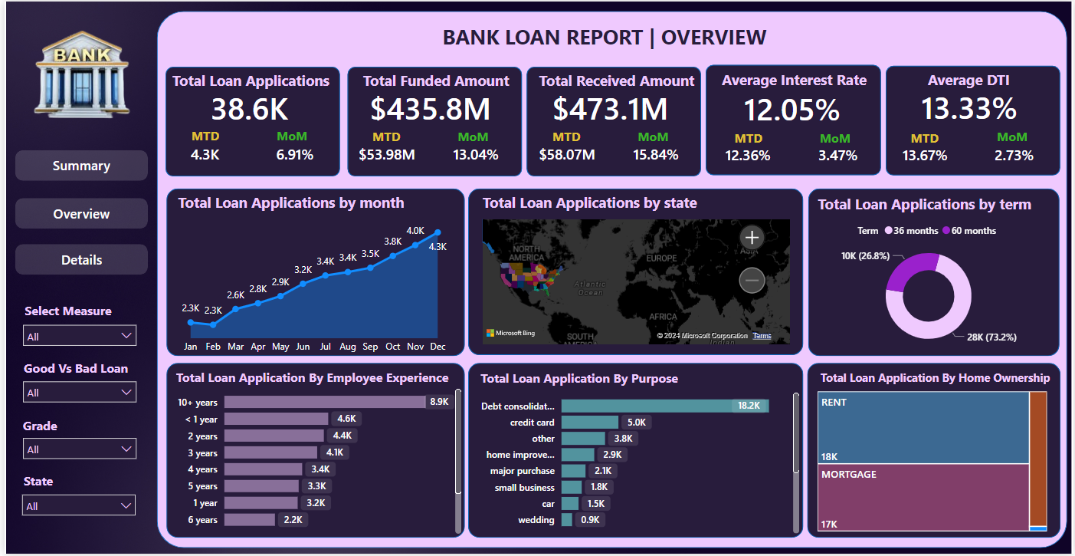

Total Loan Applications by Month:

select MONTH(issue_date) as month_no,DATENAME(MONTH,issue_date) as month,COUNT(*) as total_applications ,

SUM(loan_amount) as total_funded_amount,SUM(total_payment) as total_received_amount

from bank_loan_data

group by MONTH(issue_date),DATENAME(MONTH,issue_date)

order by MONTH(issue_date);

Total Loan Applications State Wise:

select address_state as State,COUNT(*) as total_applications ,

SUM(loan_amount) as total_funded_amount,SUM(total_payment) as total_received_amount

from bank_loan_data

group by address_state

order by total_applications desc,total_funded_amount desc;

Term Wise Percentage:

select term,COUNT(*) as total_applications ,

SUM(loan_amount) as total_funded_amount,SUM(total_payment) as total_received_amount,

(CASE

When term='36 months' then 100*CAST((select count(*) from bank_loan_data where term='36 months') as decimal(10,2))/CAST((select count(*) from bank_loan_data ) as decimal(10,2))

When term='60 months' then 100*CAST((select count(*) from bank_loan_data where term='60 months') as decimal(10,2))/CAST((select count(*) from bank_loan_data) as decimal(10,2))

END) as percentage_of_composition

from bank_loan_data

group by term;

Employee Experience Wise:

select emp_length,COUNT(*) as total_applications ,

SUM(loan_amount) as total_funded_amount,SUM(total_payment) as total_received_amount

from bank_loan_data

group by emp_length

order by total_applications desc , total_funded_amount desc;

Purpose Wise:

select purpose,COUNT(*) as total_applications ,

SUM(loan_amount) as total_funded_amount,SUM(total_payment) as total_received_amount

from bank_loan_data

group by purpose

order by total_applications desc , total_funded_amount desc;

Home Ownership Wise:

select home_ownership,COUNT(*) as total_applications ,

SUM(loan_amount) as total_funded_amount,SUM(total_payment) as total_received_amount

from bank_loan_data

group by home_ownership

order by total_applications desc , total_funded_amount desc;

----------------------------------Details Dashboard ----------------------------------------------

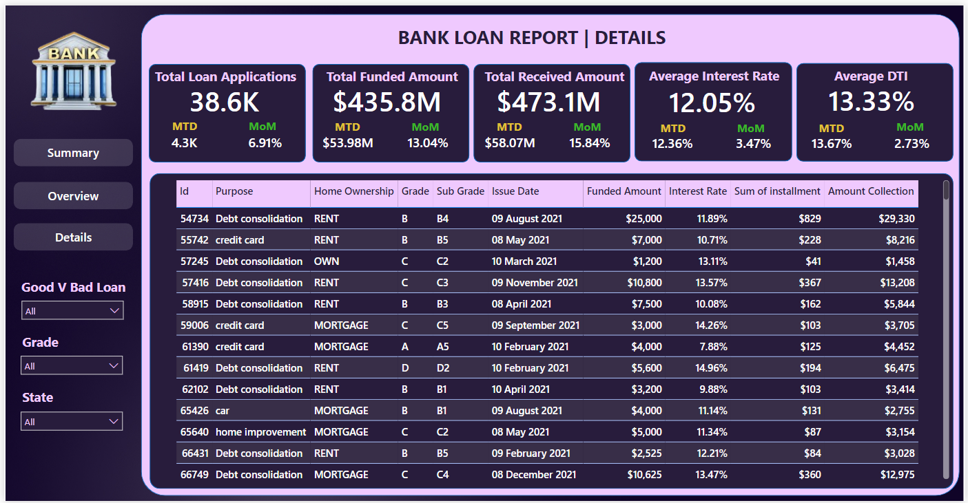

Details:

select id,purpose,home_ownership,grade,sub_grade,issue_date,loan_amount as Funded_Amount,int_rate as Interest_Rate,installment,total_payment as Amount_Collection

from bank_loan_data

order by id;

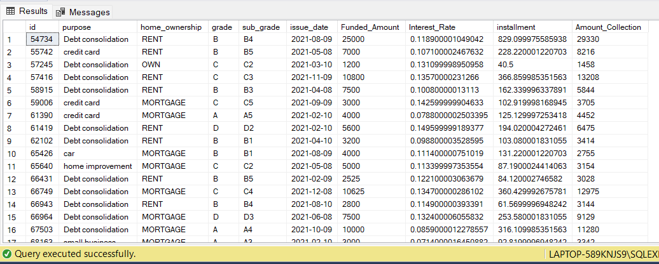

-------------------------------------------------Filters------------------------------------------------

1: Purpose Credit Card , Grade D , State – TX (Texas)

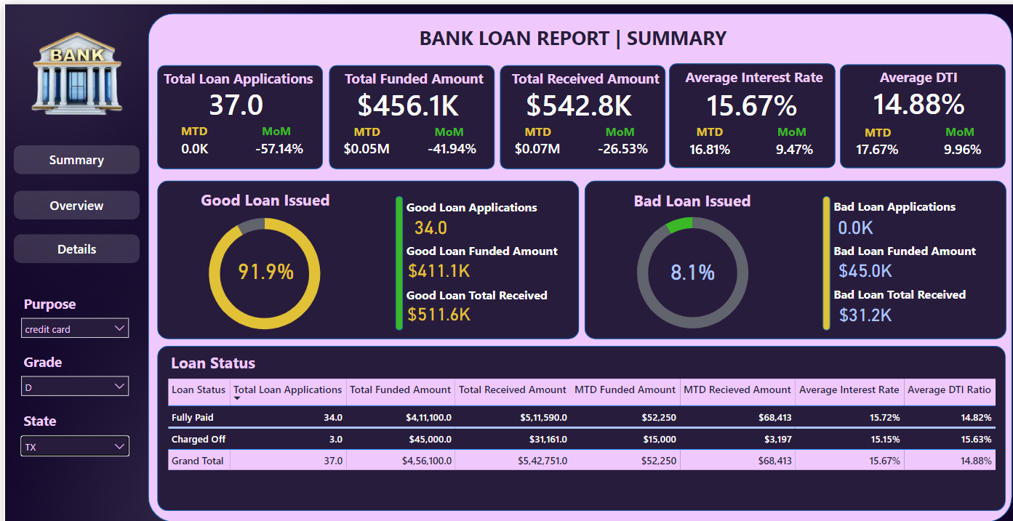

select COUNT(*) as total_applications ,SUM(loan_amount) as Funded_Amount , SUM(total_payment) as Received_Amount from bank_loan_data

group by purpose,grade,address_state

having purpose='credit card' and grade='D' and address_state='TX';

2.Bad Loan , Grade C , Find Total Applications by purpose

select purpose , COUNT(*) as Loan_Applications_By_Purpose from bank_loan_data

where loan_status='charged off'

group by grade,purpose

having grade='C'

order by Loan_Applications_By_Purpose desc;

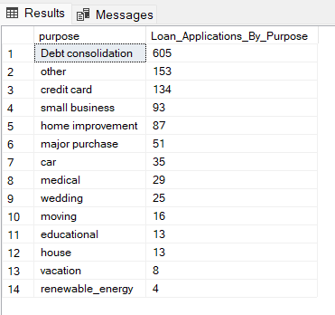

3:Good Loan , Grade -A, State-DC, Find Total Loan Application by term

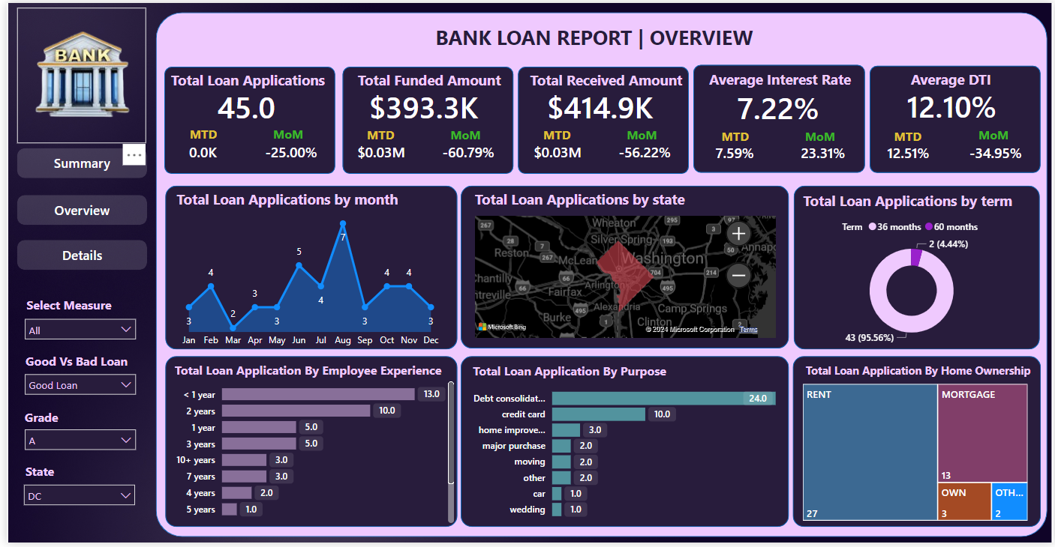

select term,COUNT(*) as total_loan_applications_by_term from bank_loan_data

where loan_status not in ('charged off')

group by term,grade,address_state

having grade='A' and address_state='DC';

4:Grade-F , Month on Month Funded Amount

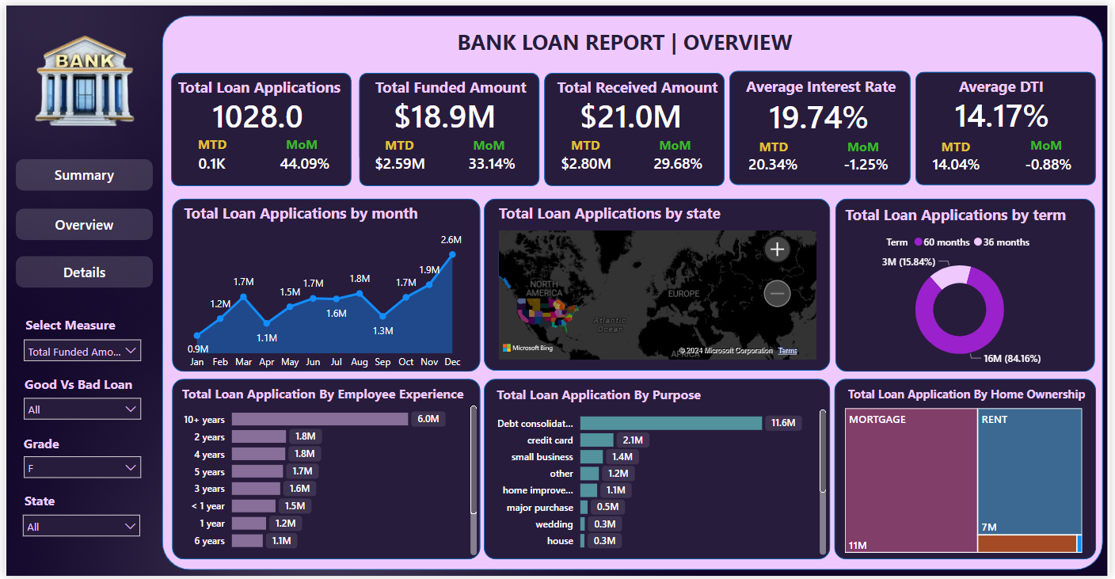

select MONTH(issue_date) as month_no,DATENAME(MONTH,issue_date) as month_name ,SUM(loan_amount) as funded_amount from bank_loan_data

group by grade,MONTH(issue_date),DATENAME(MONTH,issue_date)

having grade='F'

order by month_no;

5:Bad Loan , Grade-G , State- CA , Find Details

select id,purpose,home_ownership,grade,sub_grade,issue_date,loan_amount as Funded_Amount,int_rate as Interest_Rate,installment,total_payment as Amount_Collection

from bank_loan_data

where grade='G' and address_state='CA' and loan_status='charged off'

order by id;

Thanks For Reading

Regards

Dhruvik Detroja